**Daily Scrum or Standup Meeting**

Team name: ________Group 2_________________

Scrum Master: ______Emily_________________

Date:________11/3_______________________

| **Team Member** | **What did you do since the last scrum?** | **What do you plan to do before the next scrum?** | **What obstacles do you have?** |
| --- | --- | --- | --- |
| Emily | Search user name in cashier view, update prices at correct trigger points | Wait for orders to be ready for customers to buy | Prerequisite for this task doesn’t exist yet |
| Maris Hurst | Freed up time | Implement the through model | time |
| Andre Nguyen | Write unit test | Create more unit tests and update the documentation | Feeling Ill |
| Karl Poulson | Additional styling | Understand the many to one relationships | Broken PC |
|  |  |  |  |

# Burndown

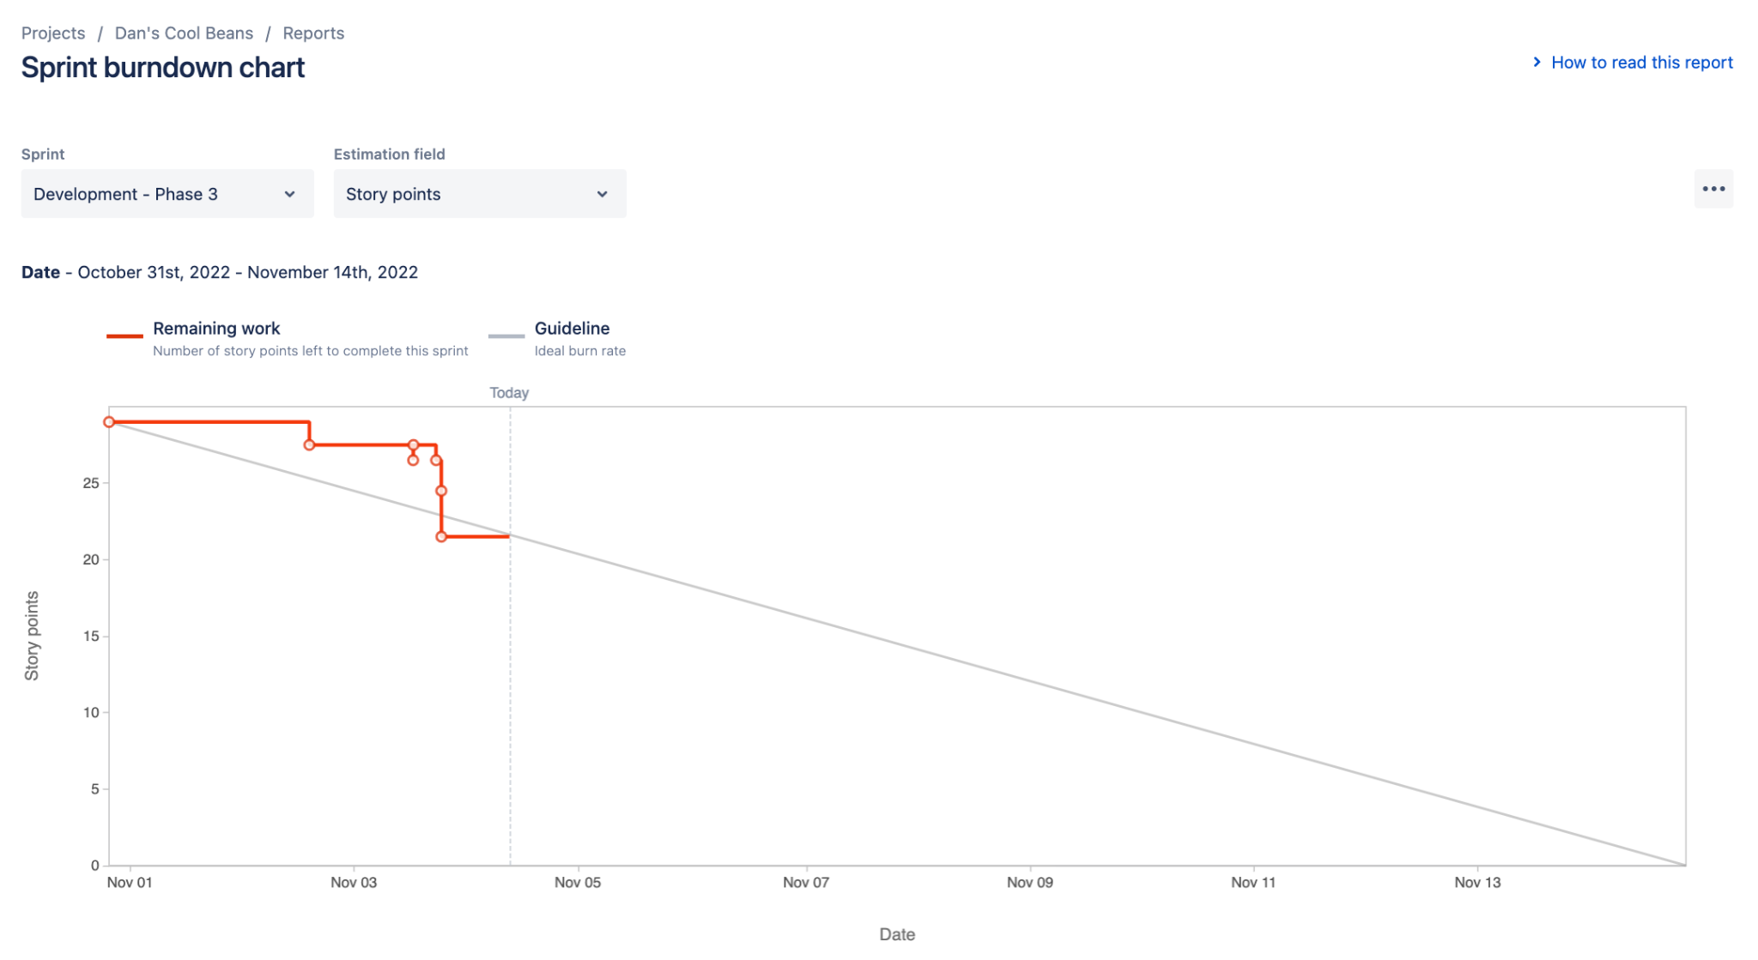

# Screenshot of you project board

